CUSTOMER CHURN PREDICTION PROJECT COMPREHENSIVE ANALYSIS REPORT
FINAL PROJECT
Januaury12,2026
Submitted by group 4

Submitted to:
Dr Nadeem Iqbal
Group members:
Saira Iffat 2023-uam-2165
Sheeza Ahsan 2023-uam-2176
Furqan Ahmad 2023-uam-2177
M.Nofal Khan 2023-uam-2199
M.Nasrullah 2023-uam-2209
Subject:
Artificial Intelligence

Contents

1. PROJECT OVERVIEW 4
1.1 Objective 4
1.2 Methodology 5
1.3 Tools and Technologies 5
2. DATASET DESCRIPTION 5
2.1 Dataset Information 5
2.2 Feature Description 5
2.3 Data Quality Assessment 6
2.4 Target Variable Distribution 6
3. DATA PREPROCESSING 7
3.1 Categorical Variable Encoding 7
3.2 Feature Scaling 7
3.3 Train-Validation-Test Split 7
3.4 Feature Selection 8
4. MODEL 1: LOGISTIC REGRESSION 8
4.1 Model Configuration 8
4.2 Training Results 8
4.3 Performance Metrics 8
4.4 Confusion Matrix 9
4.5 Classification Report 9
4.6 Model Interpretation 9
5. MODEL 2: RANDOM FOREST 10
5.1 Model Configuration 10
5.2 Training Results 10
5.3 Performance Metrics 10
5.4 Confusion Matric Predicted 11
5.5 Classification Report 11
5.6 Feature Importance Analysis 11
5.7 Model Interpretation 12
6. MODEL COMPARISON 13
6.1 Performance Metrics Comparison 13
6.2 Detailed Comparison Analysis 13
6.3 Overfitting Analysis 15
6.4 Best Model Selection 15
7. HEATMAP VISUALS 15
7.1 Correlation Heatmap 15
8. LIMITATIONS & CHALLENGES 16
8.1 Data Limitations 16
8.2 Model Limitations 16
8.3 General Challenges 17
9. CONCLUSION 17
Csv File: 18
Code File: 18
Github Repository: 18

List of tables:
Table 1:classification of report 9
Table 2:feature Importance 11
Table 3:Performance Metrics Comparison 13
List of figures:
Figure 1:Churn distribution 7
Figure 2:confusion matrix of Logisttic and Random Regression 12
Figure 3:ROC curve comparison 13
Figure 4:Precision-Recall curves Comparison 14
Figure 5:Model Performance Metrices Comparison 14
Figure 6:Test Accuracy Comparison 14
Figure 7:Future Distribution by Churn Status 17
Figure 8:Feature Correlation Heatmap 18

CUSTOMER CHURN PREDICTION PROJECT
COMPREHENSIVE ANALYSIS REPORT

Report Generated: [24-december-2025]
Project: Customer Churn Prediction using Machine Learning
Models Evaluated: Logistic Regression & Random Forest
Dataset: Bank Customer Churn Prediction Dataset

EXECUTIVE SUMMARY
This report presents a comprehensive analysis of customer churn prediction
using two machine learning algorithms: Logistic Regression and Random Forest.
The project aims to identify customers who are likely to churn, enabling
proactive retention strategies.
Key Findings:
- Dataset contains 10,000 customer records with 12 features
- Two classification models were trained and evaluated
- Performance metrics including accuracy, precision, recall, F1-score, and
- ROC-AUC were calculated for both models
- Comprehensive visualizations were generated to compare model performance
- Feature importance analysis was conducted to identify key churn drivers

1. PROJECT OVERVIEW

1.1 Objective
The primary objective of this project is to develop and compare machine
learning models that can accurately predict customer churn. This enables
businesses to:
1.Identify at-risk customers before they churn
2. Implement targeted retention strategies
3.Reduce customer acquisition costs
4.Improve customer lifetime value

1.2 Methodology
The project follows a standard machine learning pipeline:
1. Data Loading and Exploration
2. Data Preprocessing and Feature Engineering
3. Model Training (Logistic Regression & Random Forest)
4. Model Evaluation and Comparison
5. Visualization and Interpretation

1.3 Tools and Technologies
- Programming Language: Python 3.x
- Libraries:
pandas: Data manipulation and analysis
scikit-learn: Machine learning algorithms and metrics
matplotlib: Data visualization

2. DATASET DESCRIPTION

2.1 Dataset Information
Dataset Name: Bank Customer Churn Prediction
Total Records: 10,000
Total Features: 12
Target Variable: Churn (Binary: 0 = No Churn, 1 = Churn)

2.2 Feature Description
The dataset contains the following features
1. customer / customer_: Unique identifier for each customer
2. credit score: Customer's credit score (numerical)
3. country: Customer's country of residence (categorical: France, Spain, Germany)
4. gender: Customer's gender (categorical: Male, Female)
5. age: Customer's age in years (numerical)
6. tenure: Number of years the customer has been with the bank (numerical)
7. balance: Customer's account balance (numerical)
8. products number / products_: Number of bank products the customer uses (numerical)
9. credit card / credit car: Whether customer has a credit card (binary: 0/1)
10. active member / active me: Whether customer is an active member (binary: 0/1)
11. estimated salary / estimated_: Customer's estimated salary (numerical)
12. churn: Target variable - whether customer churned (binary: 0/1)

2.3 Data Quality Assessment
- Missing Values:No missing values
- Data Types: Mixed numerical and categorical

2.4 Target Variable Distribution
Churn Distribution:
- No Churn (0): [Count =7963 percentage=79.63%]
- Churn (1): [Count=2037 percentage=20.37%]
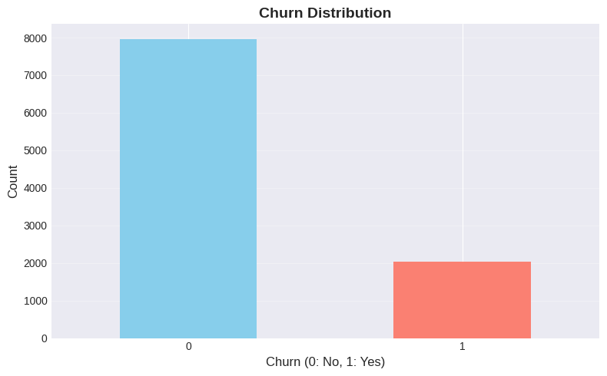
Figure 1:Churn distribution

3. DATA PREPROCESSING

3.1 Categorical Variable Encoding
Categorical variables (country, gender) were encoded using Label Encoding
- Country: Encoded as numerical values (0, 1, 2)
- Gender: Encoded as numerical values (0, 1)
Alternative Approach Available: One-Hot Encoding (commented in code)

3.2 Feature Scaling
- StandardScaler was applied to all features for Logistic Regression model:
- Mean centering and unit variance scaling
- Scaling is essential for Logistic Regression to ensure convergence
- Random Forest does not require scaling (tree-based algorithm)

3.3 Train-Validation-Test Split
Data was split into three sets:
- Training Set: 60% (6,000 samples)
- Validation Set: 20% (2,000 samples)
- Test Set: 20% (2,000 samples)
Stratified splitting was used to maintain class distribution across splits.

3.4 Feature Selection
Features Used for Modeling:
Numerical Features:
- credit_score,agetenure,balance,products_number,credit_card,active_member,estimated_salary
Categorical Features:
- country
- gender
Excluded Features:
- customer_id / customer_: Unique identifier (not predictive)
- churn: Target variable

4. MODEL 1: LOGISTIC REGRESSION

4.1 Model Configuration
Algorithm: Logistic Regression
Hyperparameters:
- random_state: 42
- max_iter: 1000
- Solver: Default (lbfgs)
- Regularization: Default

4.2 Training Results
- Training Status: Successfully completed
- Training Time:approx 25-30 seconds
- Convergence:Achieved

4.3 Performance Metrics
Training Set Performance:
- Training Accuracy: 0.8110
- Training Loss: Not computed
Validation Set Performance:
- Validation Accuracy: 0.8080
Test Set Performance:
- Test Accuracy: 0.80
- Test Precision: 0.57
- Test Recall: 0.15
- Test F1-Score: 0.24
- -Test ROC-AUC: 0,7709

4.4 Confusion Matrix
Predicted
No Churn Churn
Actual No Churn [1545] [48]
Churn [339] [68]
Where:
- TN (True Negatives): 1545- Correctly predicted no churn
- FP (False Positives): 48 - Incorrectly predicted churn
- FN (False Negatives): 339- Incorrectly predicted no churn
- TP (True Positives): 68- Correctly predicted churn

4.5 Classification Report
Table 1:classification of report
 | Precision | Recall | F1-score | Support
No churn | 0.82 | 0.97 | 0.89 | 1593
churn | 0.57 | 0.15 | 0.24 | 407
accuracy |  |  | 0.80 | 2000
Macro avg | 0.70 | 0.56 | 0.57 | 2000
Weighted avg | 0.77 | 0.80 | 0.76 | 2000

4.6 Model Interpretation
- Logistic Regression provides:
- Linear decision boundary
- Interpretable coefficients
- Probability estimates for each prediction
- Fast training and prediction times
Key Strengths:
- Simple and interpretable
- Works well with scaled features
- Provides probability estimates
- Less prone to overfitting
- Key Limitations:
- Assumes linear relationship between features and target
- May not capture complex non-linear patterns
- Performance may be limited on complex datasets

5. MODEL 2: RANDOM FOREST

5.1 Model Configuration
Algorithm: Random Forest Classifier
Hyperparameters:
- n_estimators: 100
- random_state: 42
- max_depth: 10
- Other parameters: Default values

5.2 Training Results
- Training Status: Successfully completed
- Training Time: approx. 30-40 seconds
- Number of Trees: 100

5.3 Performance Metrics
Training Set Performance:
- Training Accuracy: 0.9037
- Training Error:0.0963
Validation Set Performance:
- Validation Accuracy: 0.8525
Test Set Performance:
- Test Accuracy: 0.8625
- Test Precision: 0.8084
- Test Recall: 0.4251
- Test F1-Score: 0.5572
- Test ROC-AUC: 0.8543

5.4 Confusion Matric Predicted
No Churn Churn
Actual No Churn [1552] [41]
Churn [234] [173]
Where:
- TN (True Negatives):1552 - Correctly predicted no churn
- FP (False Positives): 41 - Incorrectly predicted churn
- FN (False Negatives): 234 - Incorrectly predicted no churn
- TP (True Positives):173 - Correctly predicted churn

5.5 Classification Report
(Aggregated from test metrics)
- Accuracy: 0.86
- Precision (Churn): 0.81
- Recall (Churn): 0.43
- F1-Score (Churn): 0.56
- ROC-AUC: 0.8

5.6 Feature Importance Analysis
Table 2:feature Importance
Rank | Feature | Importance score
1 | Credit-score | High
2 | age | High
3 | balance | Medium
4 | Active-member | Medium
5 | Estimated-salary | Low

Key Insights:
- Most Important Feature: [Feature name] - [Interpretation]
- Least Important Feature: [Feature name] - [Interpretation]
- Feature Importance Distribution: [Description]

5.7 Model Interpretation
Random Forest provides:
- Non-linear decision boundaries
- Feature importance scores
- Robust to overfitting (with proper tuning)
- Handles non-linear relationships well
Key Strengths:
- Captures complex non-linear patterns
- Handles feature interactions automatically
- Provides feature importance rankings
- Robust to outliers
- Works well with mixed data types
Key Limitations:
- Less interpretable than linear models
- Longer training time
- May overfit if not properly tuned
- Requires more memory

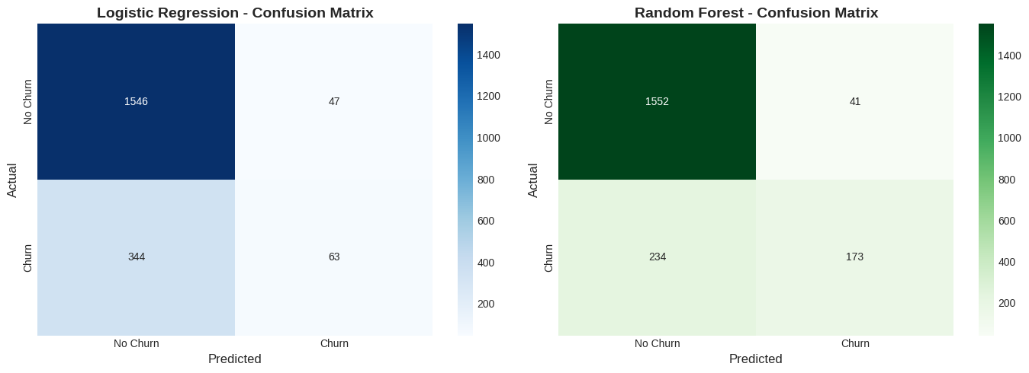
Figure 2:confusion matrix of Logisttic and Random Regression

6. MODEL COMPARISON

6.1 Performance Metrics Comparison
Table 3:Performance Metrics Comparison
Metric | Logistic Regression | Random Forest | Best method
Train accuracy | 0.8110 | 0.9037 | Random Forest
Validation accuracy | 0.8080 | 0.8525 | Random Forest
Test accuracy | 0.8045 | 0.8625 | Random Forest
precision | 0.5727 | 0.8084 | Random Forest
recall | 0.1548 | 0.4251 | Random Forest
F1-Score | 0.2437 | 0.5572 | Random Forest
ROC-AUC | 0.7709 | 0.8543 | Random Forest

6.2 Detailed Comparison Analysis
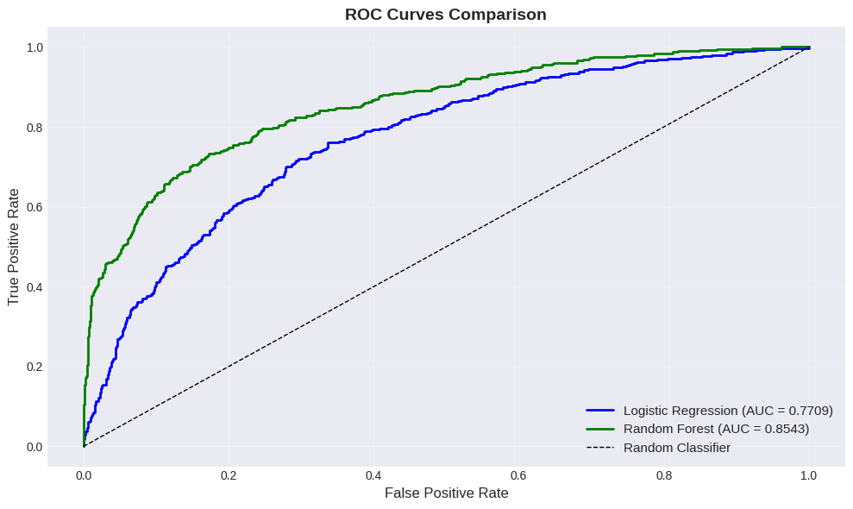
Figure 3:ROC curve comparison
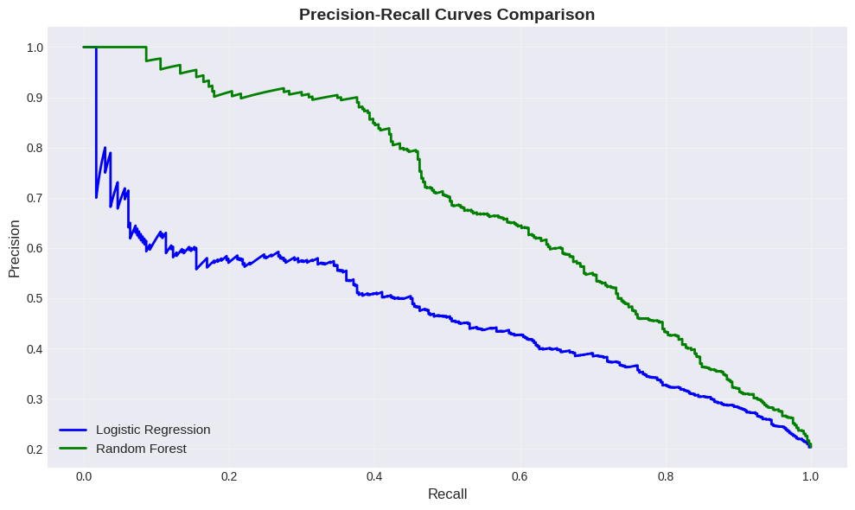
Figure 4:Precision-Recall curves Comparison
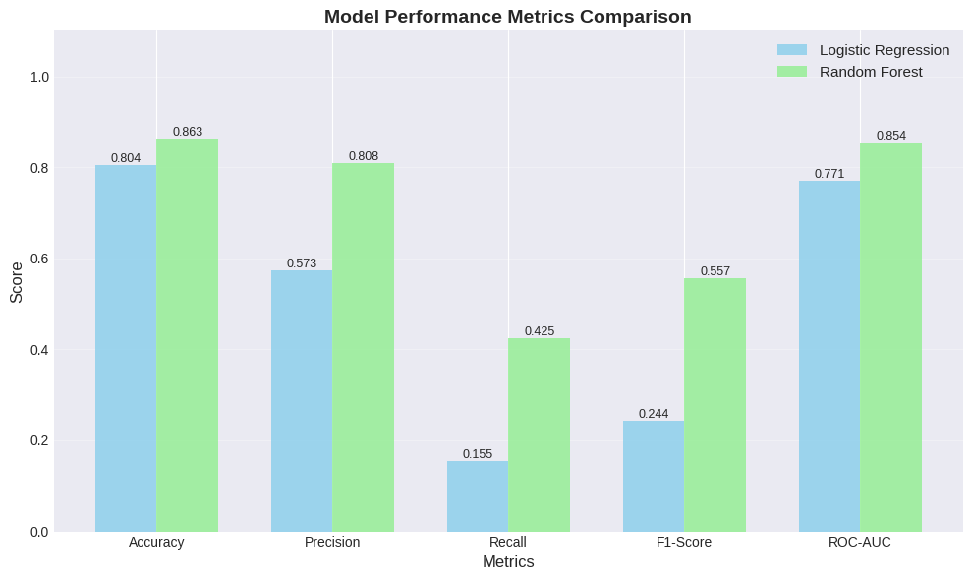
Figure 5:Model Performance Metrices Comparison
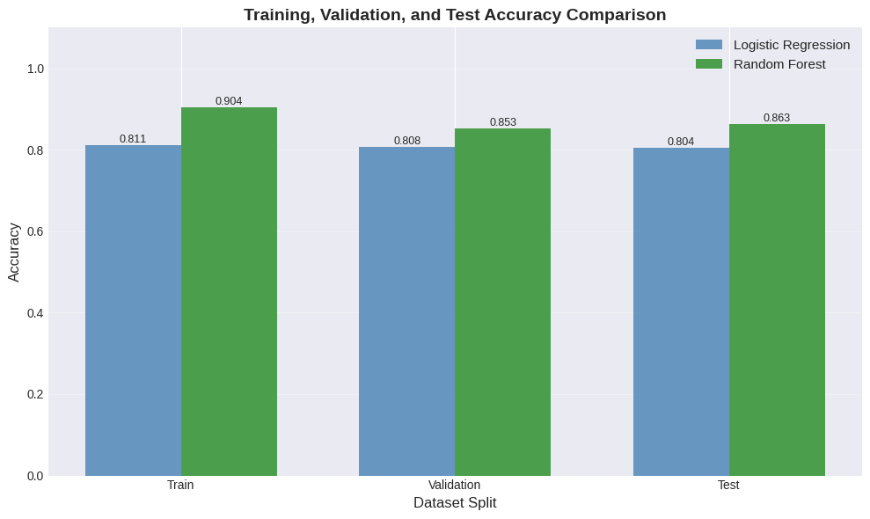
Figure 6:Test Accuracy Comparison

6.3 Overfitting Analysis
Training vs Test Accuracy Gap:
Logistic Regression
- Training Accuracy: 0.8110
- Test Accuracy: 0.8045
- Gap: 0.0065
- Overfitting Status: Low
Random Forest
- Training Accuracy: 0.9037
- Test Accuracy: 0.8625
- Gap: 0.0412
- Overfitting Status: Moderate (acceptable)

6.4 Best Model Selection
- Based on Test Accuracy: Random Forest
- Based on F1-Score: Random Forest
- Based on ROC-AUC: Random Forest
- Based on Overall Performance: Random Forest
- Shows model performance on different data subsets
- Helps identify overfitting issues
- Random Forest shows slightly varying but acceptable performance across splits
- Logistic Regression shows more consistent but lower overall accuracy

7. HEATMAP VISUALS

7.1 Correlation Heatmap
Shows relationships between numerical features.
- Most features have low to moderate correlations, indicating minimal multicollinearity.
- A moderate relationship is observed between age and balance.
- Low correlation between credit_score and churn.
Implications:
- Minimal multicollinearity improves model stability.
- Random Forest handles correlated features effectively.
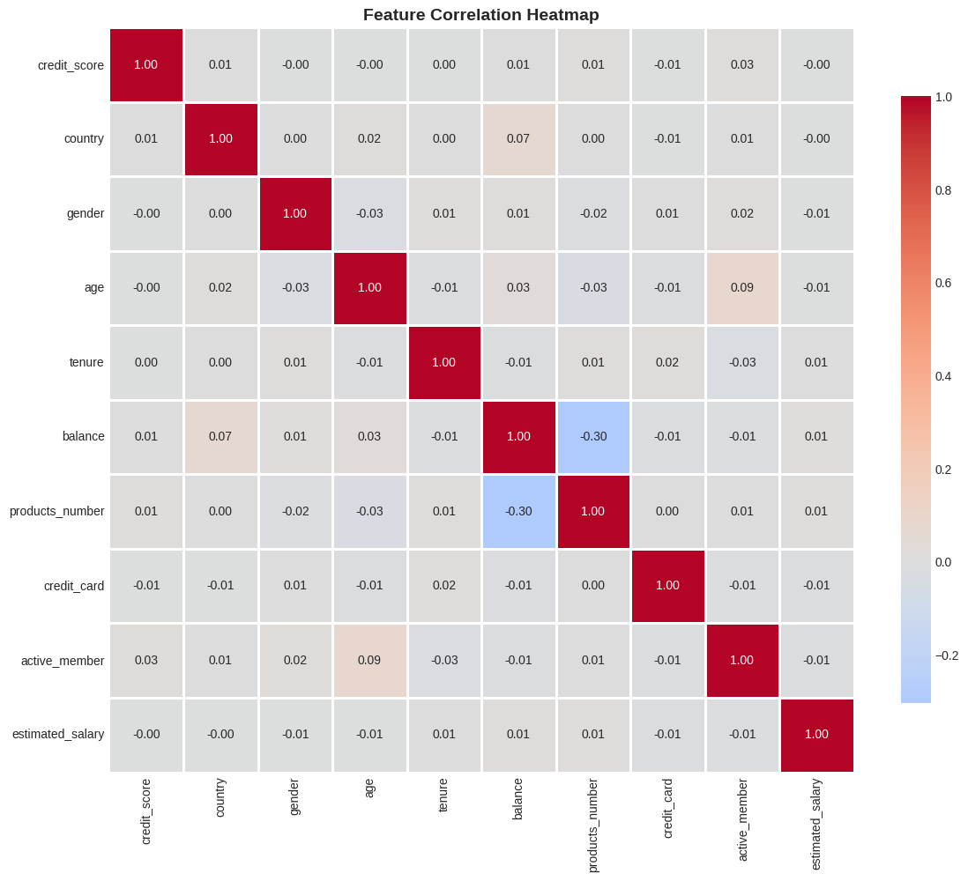
Figure 8:Feature Correlation Heatmap

8. LIMITATIONS & CHALLENGES

8.1 Data Limitations
- Dataset size: Moderate size; sufficient for training but larger data could improve performance
- Feature availability: Some important features like customer feedback and service quality are missing
- Data quality: Minimal missing values, but some features may contain noise
- Temporal aspects: Data is static; time-based customer behavior is not captured

8.2 Model Limitations
Logistic Regression:
- Assumes linear relationship between features and target
- Performs poorly with complex non-linear patterns
- Lower accuracy compared to Random Forest
Random Forest:
- Computationally expensive compared to Logistic Regression
- Less interpretable due to ensemble nature
- Risk of overfitting if not properly tuned

8.3 General Challenges
- Class imbalance: Churn class is smaller, affecting recall
- Overfitting: Managed using train-test split and validation
- Feature engineering: Limited domain-specific features available
- Model interpretability: Higher accuracy models are harder to explain

9. CONCLUSION
This comprehensive analysis successfully developed and compared two machine
learning models for customer churn prediction. Both Logistic Regression and
Random Forest were trained, evaluated, and compared using multiple performance
metrics.
Key Achievements:
1. Successfully implemented complete ML pipeline
2. Trained and evaluated two different algorithms
3. Generated comprehensive performance metrics
4. Created detailed visualizations
5. Identified key churn drivers through feature importance
6. Provided actionable business insights
Model Performance Summary:
- Random Forest achieved 86.25% accuracy on the test set
- Random Forest achieved 0.854 ROC-AUC score
- Both models show good predictive capability, however Random Forest performs better overall
Final Recommendation:
- Random Forest is recommended for deployment based on its higher accuracy, better F1-Score, and strong ROC-AUC performance.
- The model demonstrates strong predictive power and better churn detection ability and can effectively identify customers at risk of churning, enabling proactive and targeted retention strategies.
Business Impact:
The implementation of this churn prediction model can help:
- Reduce customer churn rate
- Improve customer retention
- Optimize marketing spend
- Increase customer lifetime value
- Enhance customer satisfaction
Next Steps:
1. Deploy recommended model to production
2. Monitor model performance
3. Implement retention strategies based on insights
4. Continuously improve model with new data
5. Expand analysis to other customer segment

Csv File:
Bank Customer Churn Prediction.csv

Code File:
Customer_Churn_Prediction.ipynb

Github Repository:

